Task 1:

 Amazon prime is a popular streaming service that offers a vast catalo of movies, TV shows, and original content. The data consist of contents added to Prime from 2008 to 2021. The oldest content is as old as 1925 and the newest is 2021 (see attachment prime.csv). The tasks that you need to perform are

* Undertake exploratory data analysis and produce a 2-page report on your findings/insights
* Clean the data and produce good visualization for storytelling
* Submit your code and report via the GitHub repo

Data Describe

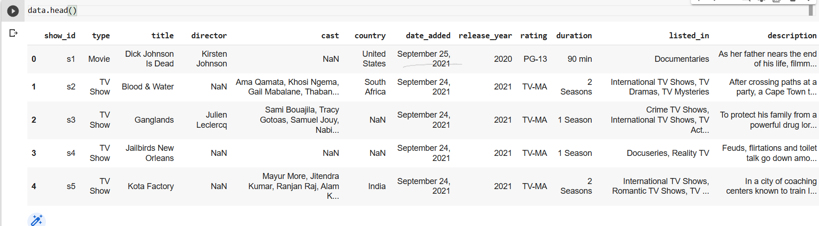

 The Amazon Prime to the Popular streaming Services the Describe the Data’s

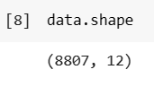

The Dataset to the Shape of the Values in 8807 of columns or rows in the attributes

Data Cleaning

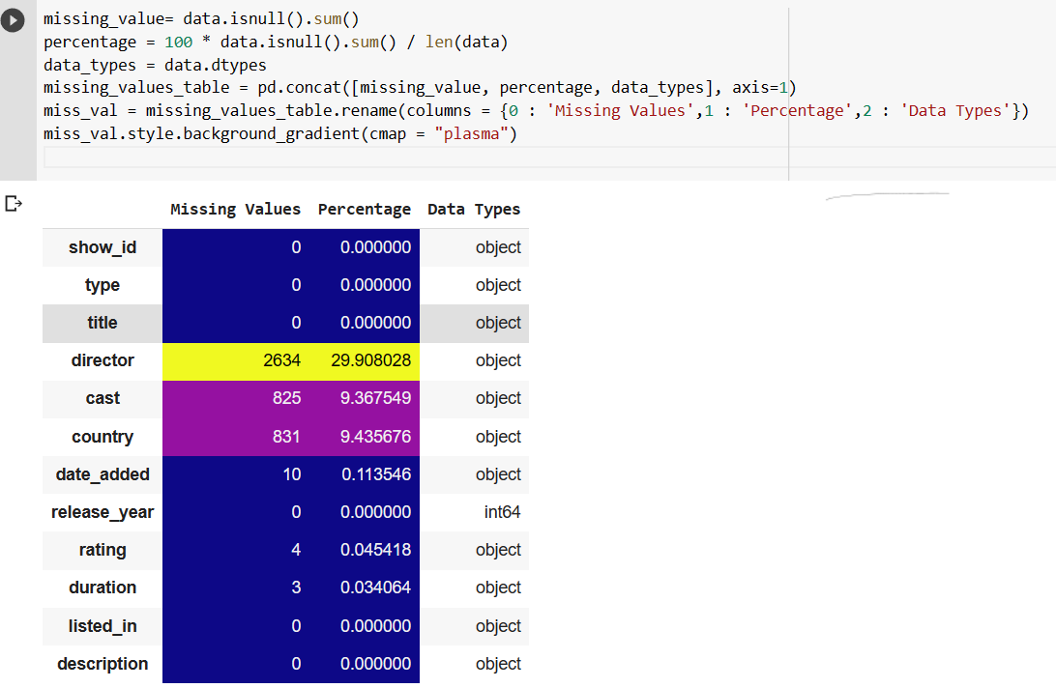

The Data Cleansing for the replacement of the values in the director, cast, and rating for the missing values to refill the missing values to refill the mean and median on the report to refill the NAN values

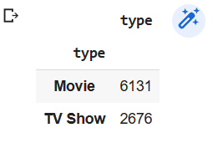

The Movies watching the users 6131 and tv show to the comparison on the 2676

The Country wised to watching the shows on the peoples

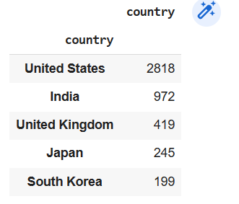 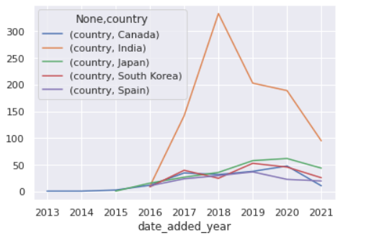

After 2016, India saw a boom, and over time, the other four countries also experienced some growth. But not nearly as much as we may have anticipated. Yet, it appears that Netflix is gradually expanding the selection of international films they provide over time.

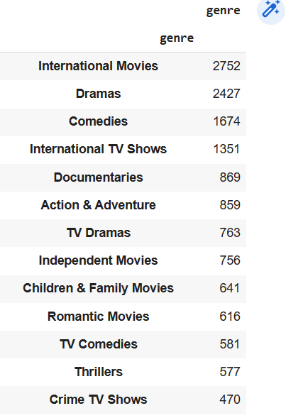

The Nation Wised to the based on the Recommendation on the watching the people on the majority of the people highly recommended of the people viewed in the international movies to the repositories